**CSYE 7374: Team 9 Project Report**

1. **Group Members**

* Shaunak Prabhu 001056494
* Ayushi Deval 001344421

1. **Project Topic:**

**Deep Learning, using parallel methods, to detect celebrity features on CelebFace dataset**

1. **Introduction**

**i) Background**

The 2 methodologies we came across and decided to move forward with for our analysis are

the following:

* Convolutional Neural Network(CNN): It is a type of neural network that allows for extraction of higher representation of image content. CNN takes images in raw pixel data, trains the model , then extracts the features from it and gives a better classification output

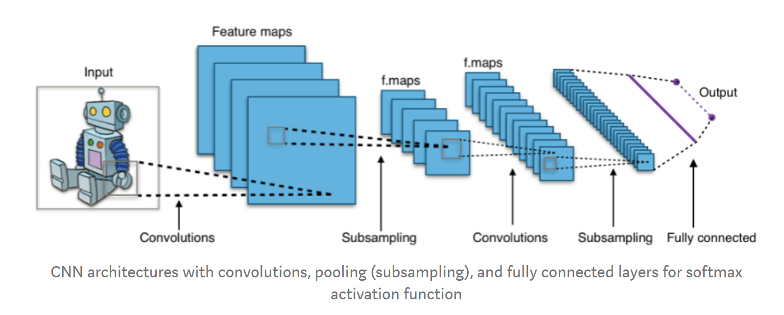

* Generative adversarial network(GAN): which is about creating images; like drawing a portrait. The main focus of GAN’s is to generate data from scratch, which are mostly images. It is a neural network architecture with a game theoretic approach, the 2 model components are generator and discriminator. The role of the generator is to fool the discriminator with fake images and the discriminator learn how not to get fooled and identify the fake images

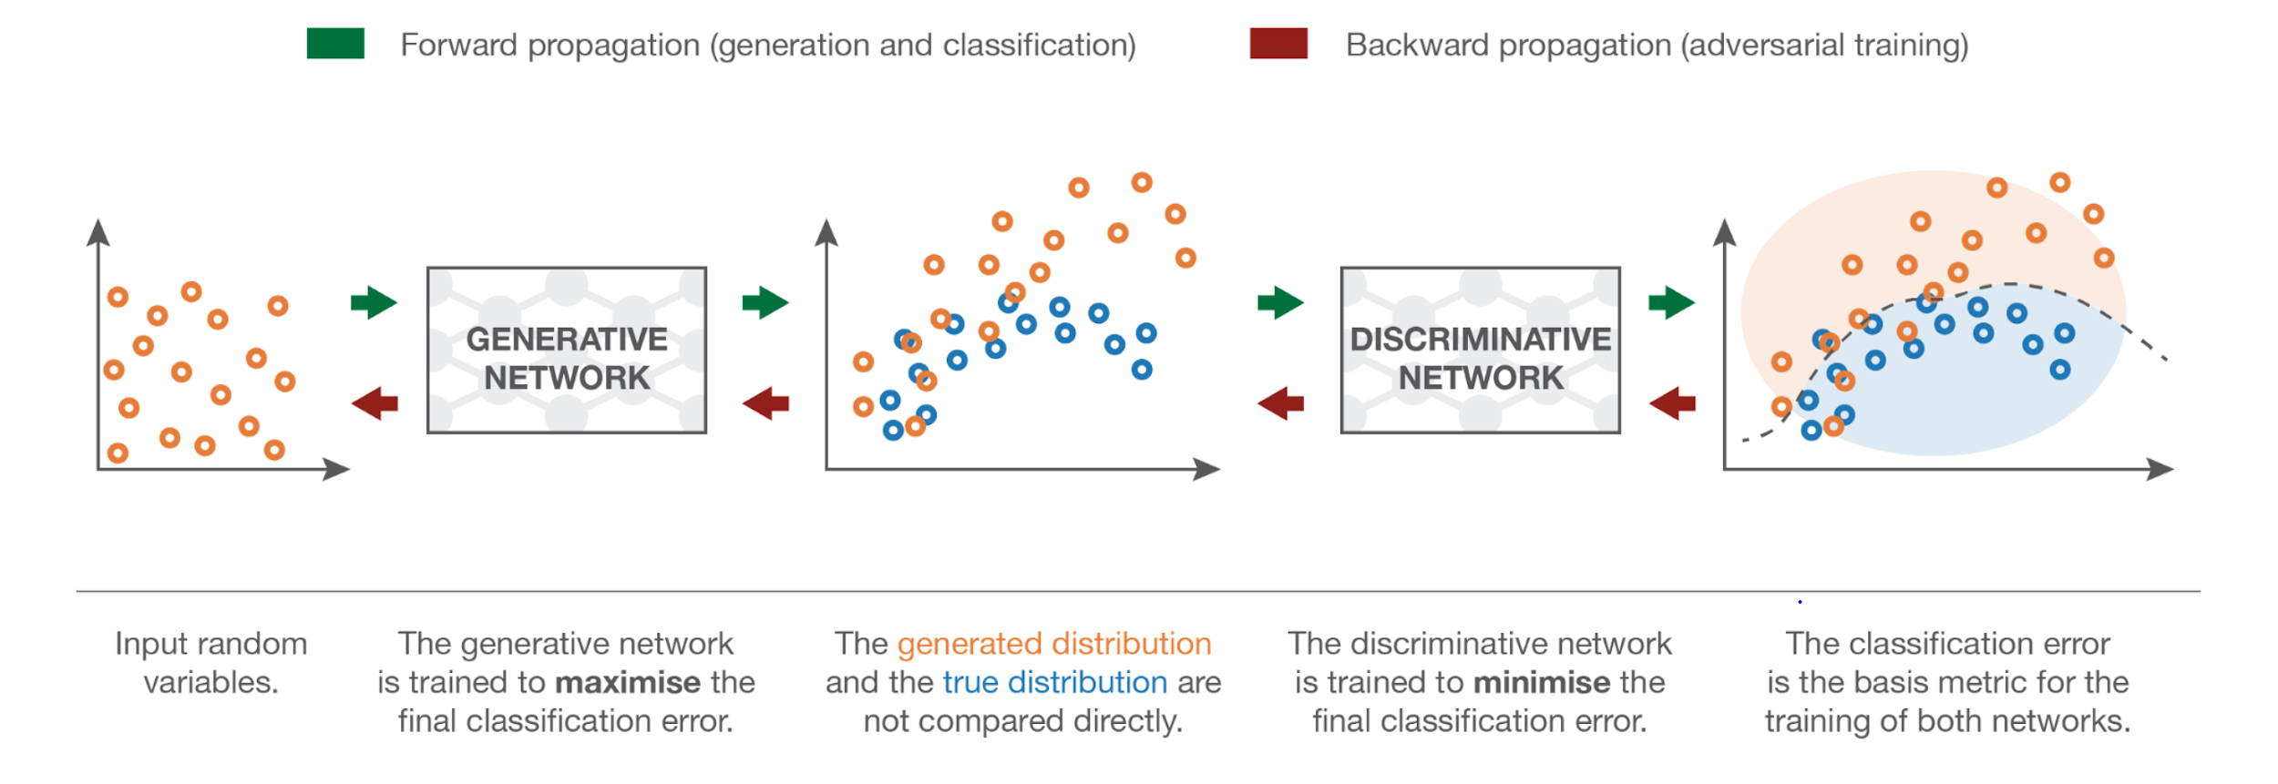

**ii) Motivation**

In recent years, the amount of data being used and created by companies and people has grown exponentially. This has led many avenues to come out to the forefront that make use of data to construct models and systems to further optimize a company’s services and provide a better consumer experience. Deep learning is a popular tool that has grown tremendously and has applications in many real life scenarios. These models are used to create artificial intelligence in a system to perform a certain human task and learn through past data. In our project we focused on using two such methods: Convolutional Neural Networks, and Generative Adversarial Networks.

Convolutional Neural Networks is one such deep learning tool which is primarily used on image data and consists of having layers upon layers of nodes with multiple channels and a convolution mask to analyze the pixel values of each image and to learn and accordingly adjust the weights of the model.

GAN’s is an unsupervised method of learning and is primarily used for data generation. Our project group decided to work with GAN’s to get a better understanding of how to create such a network.

**iii) Goals:**

The goal of this project was to make predictions on the celebrity face dataset using deep learning algorithms. We were set to predict the hair features for the celebrities and guess their gender using Convolutional Neural Network (CNN). We also decided to generate fake faces using Generative adversarial network (GAN).

1. **Methodology:**

With the goal set for the project to make predictions for the celebrity images dataset. We decided to move forward with 2 methods

1. Convolutional Neural Network (CNN)
2. Generative adversarial network (GAN)

Using Pytorch and parallelizing it using cuda on multiple GPU’s

**Step 1: Gender Prediction with CNN on Pytorch**

* Exploratory Data Analysis:

1. The attribute csv file had the column values of -1 and 1 which we change to 0

and 1 for better prediction

1. The partition csv file had all the training, validation and test data in one with values 0,1 and 2 for identification which we split into 3 different files.

* With using a custom dataset in Pytorch we had to construct our own class for loading this dataset.

This required three functions:

1. __init__: Used to initialize the csv, the image directory, and the transforms
2. __len__: Returns the length of the images within the csv
3. __getitem__: Joins the paths images with their respective labels and returns the values

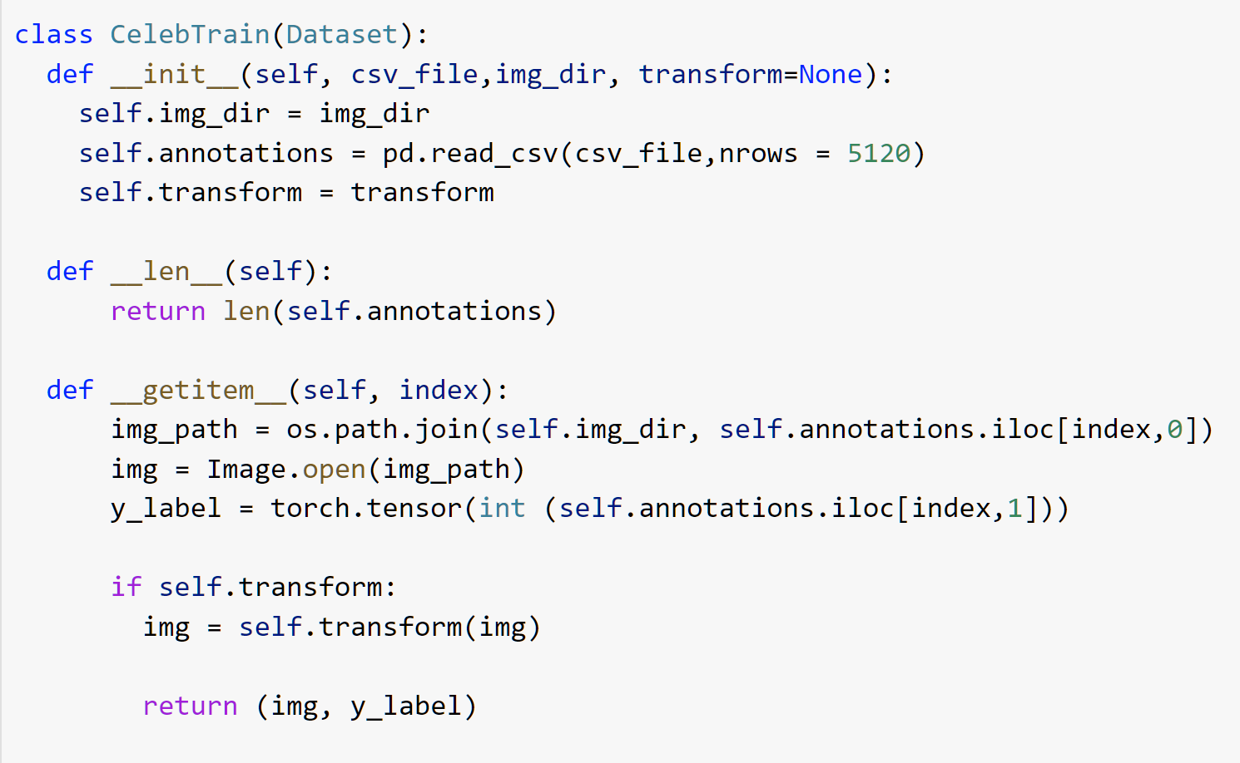

* With CNN we performed image classification of the celebrity images predicting the gender they belong to using the gender column in the attribute csv file of our dataset.

Below is the code snippet of the CNN model for gender prediction

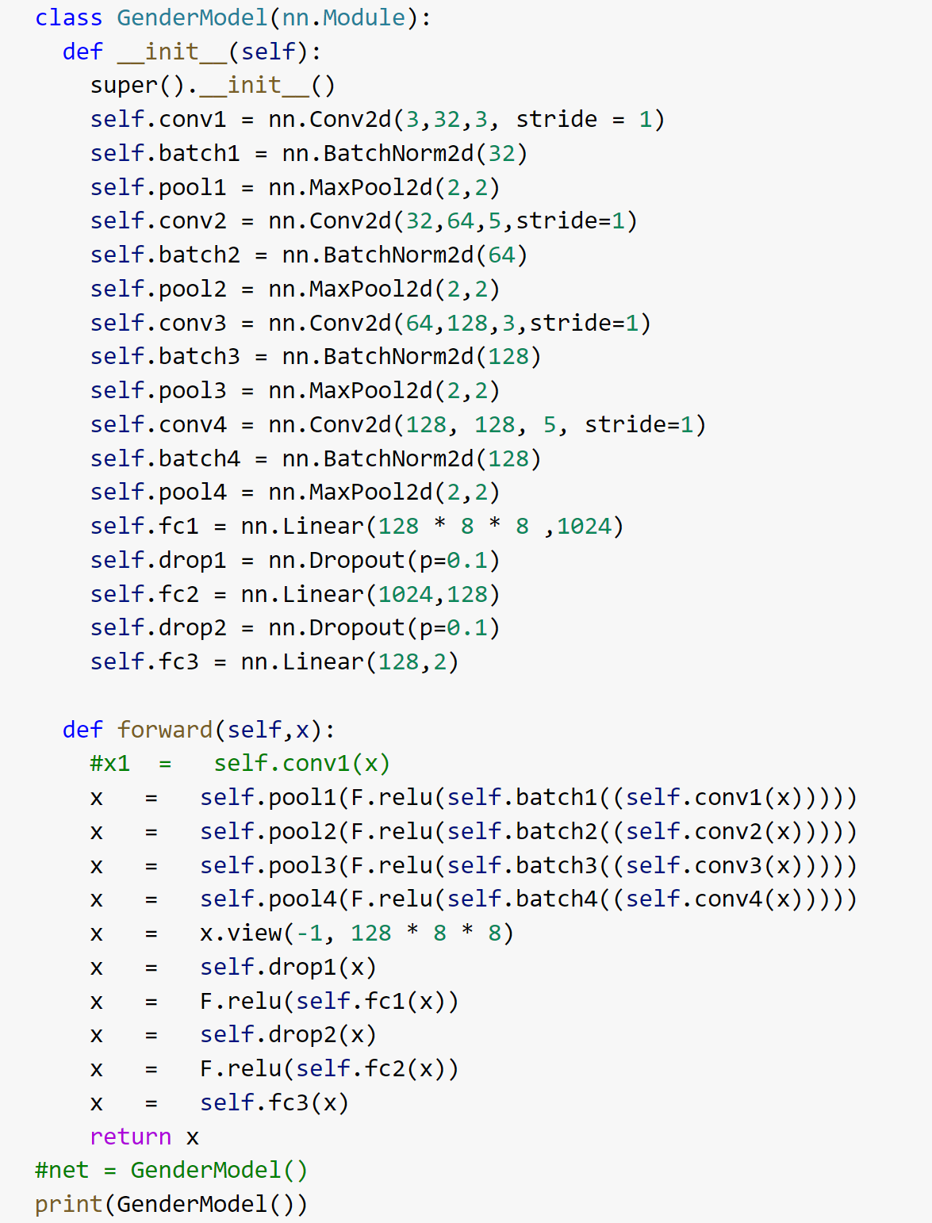

* We designed the CNN model for gender prediction with 4 layers which was able to learn on the training dataset and predict the correct gender when tested on the test dataset with an accuracy of 94%

The model was trained using a train function

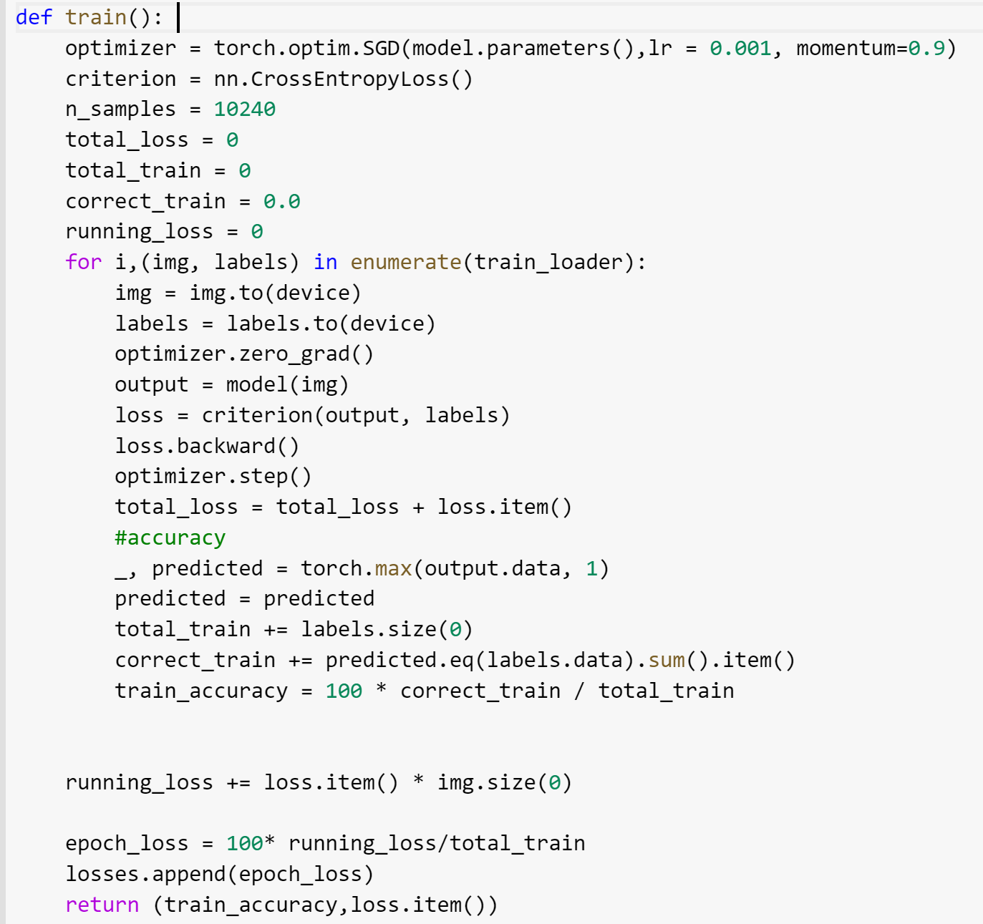

The model was validated running the epochs on the validation dataset

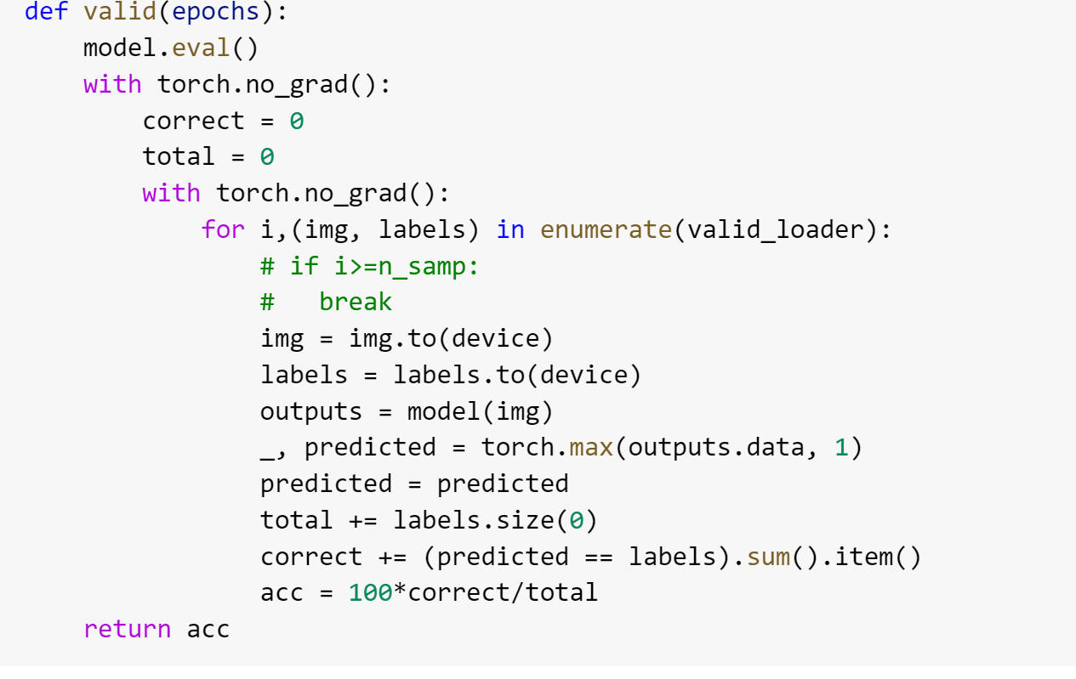

We tested the model through a Predict function

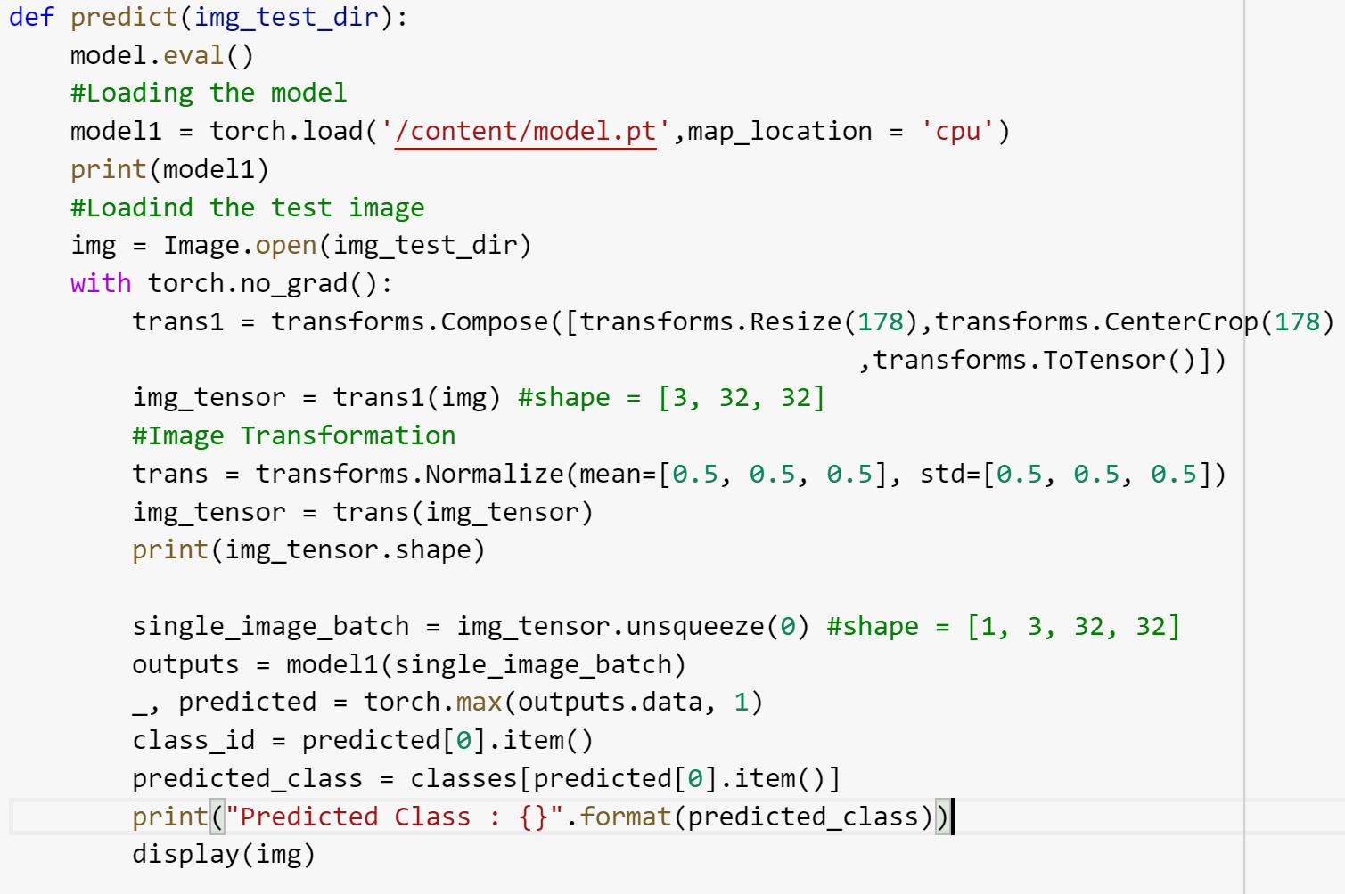

**Step 2: Hair feature Prediction Using CNN with pytorch**

* Exploratory Data Analysis:

1. The attribute file had the values with -1 and 1 for the 4 hair colors which we changed to 0 and 1 for better prediction
2. The partition csv file had all the training, validation and test data in one with values 0,1 and 2 for identification which we split into 3 different files.
3. The data was not accurate with incorrect values for hair colors as many had 0 value for all the colors, which was removed using the below code and saved into a new csv file.

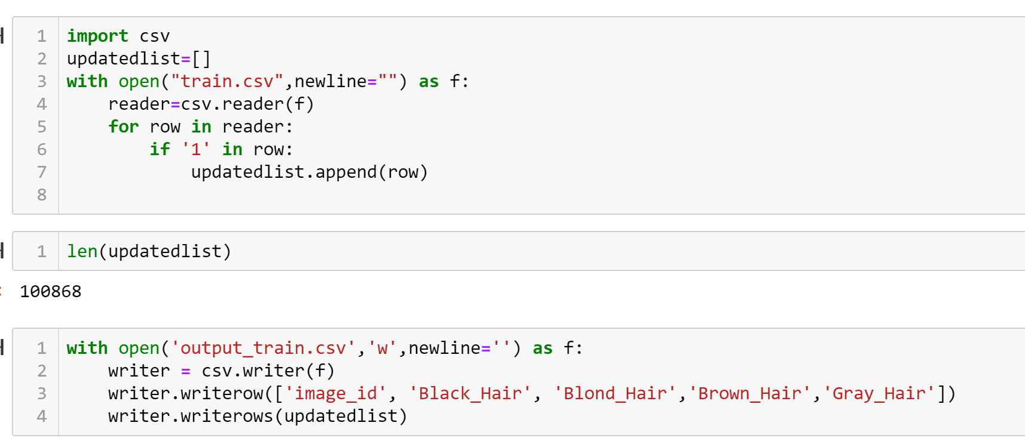

1. The 0 and 1 values of different columns were difficult to make accurate predictions, to overcome this problem a new hair color class was created.

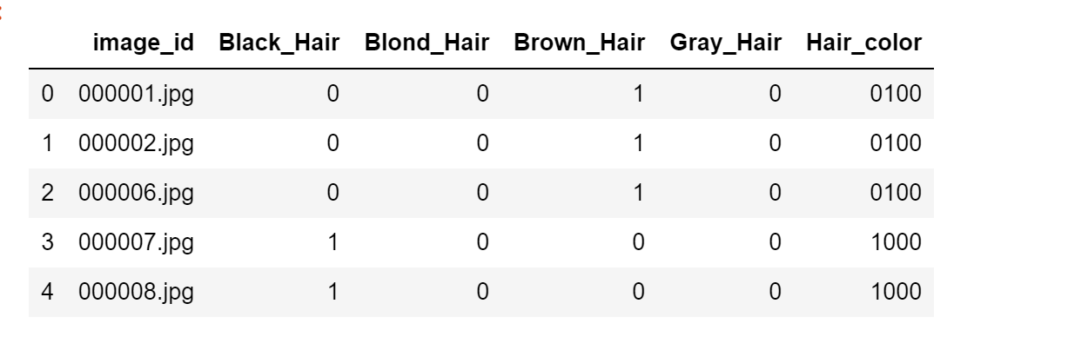

And the assigned proper numbers to the colors as 0,1,2 and 3

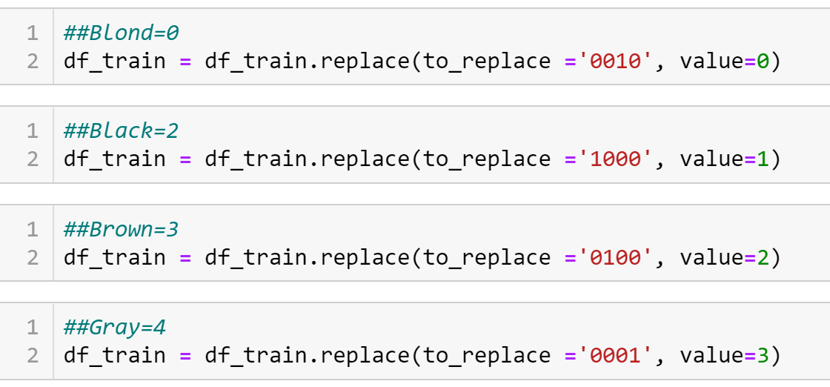

* The second part for the classification we performed hair color prediction for the celebrities with the 4 different hair colors from the data i.e Black, Brown, Blond and Gray.

Below is the model design for Hair feature prediction

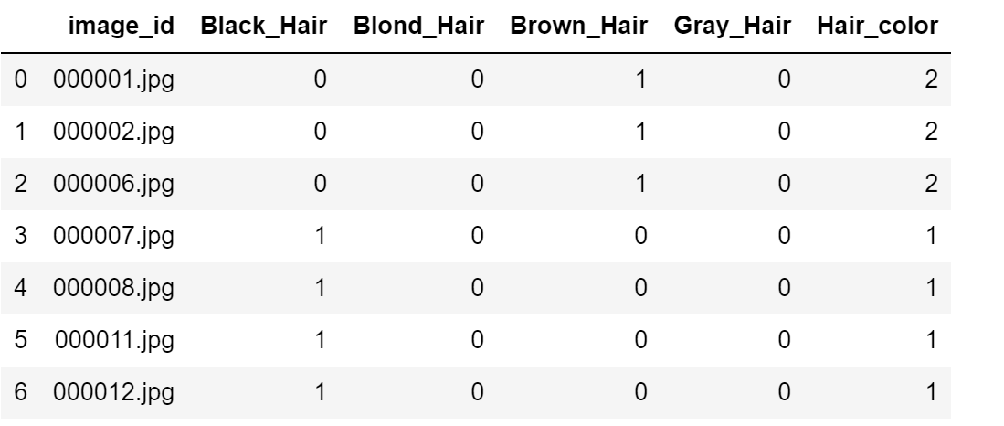

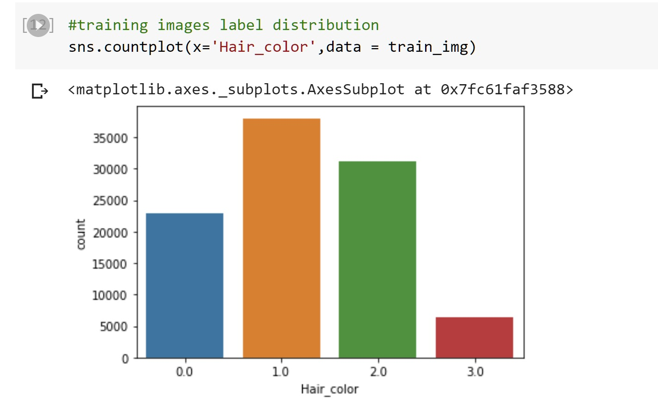

* The model learned through the train and validation data split and was able to give the correct results for the test data for the model predicting the hair color for the images with an accuracy of 93%

The train and validation images dataset was read using the below function.

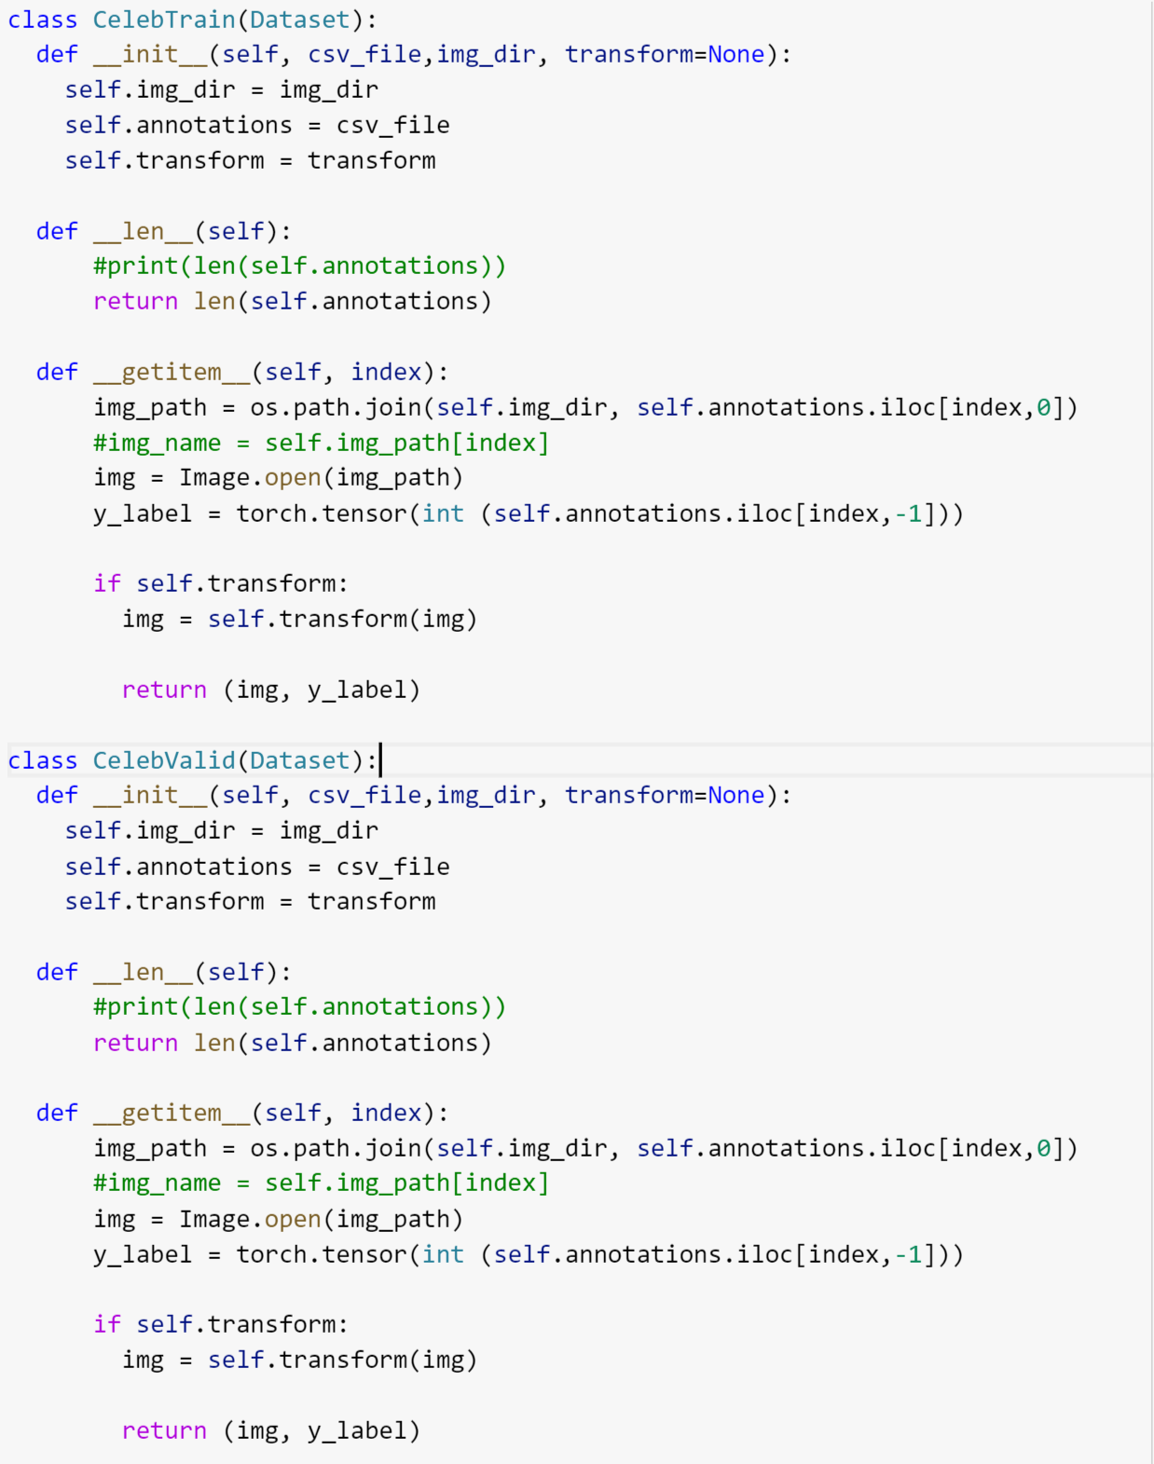

For loading the dataset we used data loader and than transformed it to tensors with their labels 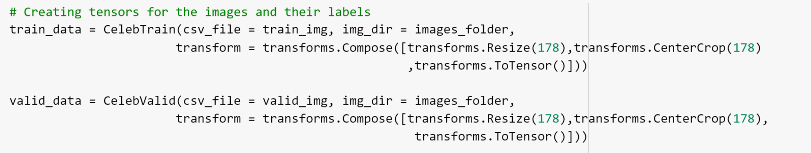

With this we resize the size of the image as it was not in proportion so to make it equal size, we transformed the image to 178 x 178

The training and the validation functions wee same for both the CNN models

Functions used in the CNN models (Gender and Hair)

1. Activation Function: ReLu as this is more computationally efficient and has better convergence .
2. Cost Function: SGD as it is easier to fit into memory and the convergence is faster with larger datasets.
3. Loss Function: Cross Entropy as it is good to work with classification problems
4. Dimensionality Reduction using MaxPool
5. Dropout is good to avoid over memorization thus reducing the complexity
6. Batch Normalization is good to check if each node is able to learn.

**Step 3: Generating fake faces using Generative adversarial network(GAN)**

**with Pytorch**

GAN is composed of two models:

* The first is the Generator model that has an aim to generate new data similar to the original input data. The Generator can be compared to a human art forger, who creates fake works of art. We designed the generator model to generate fake images for the dataset of celebrities

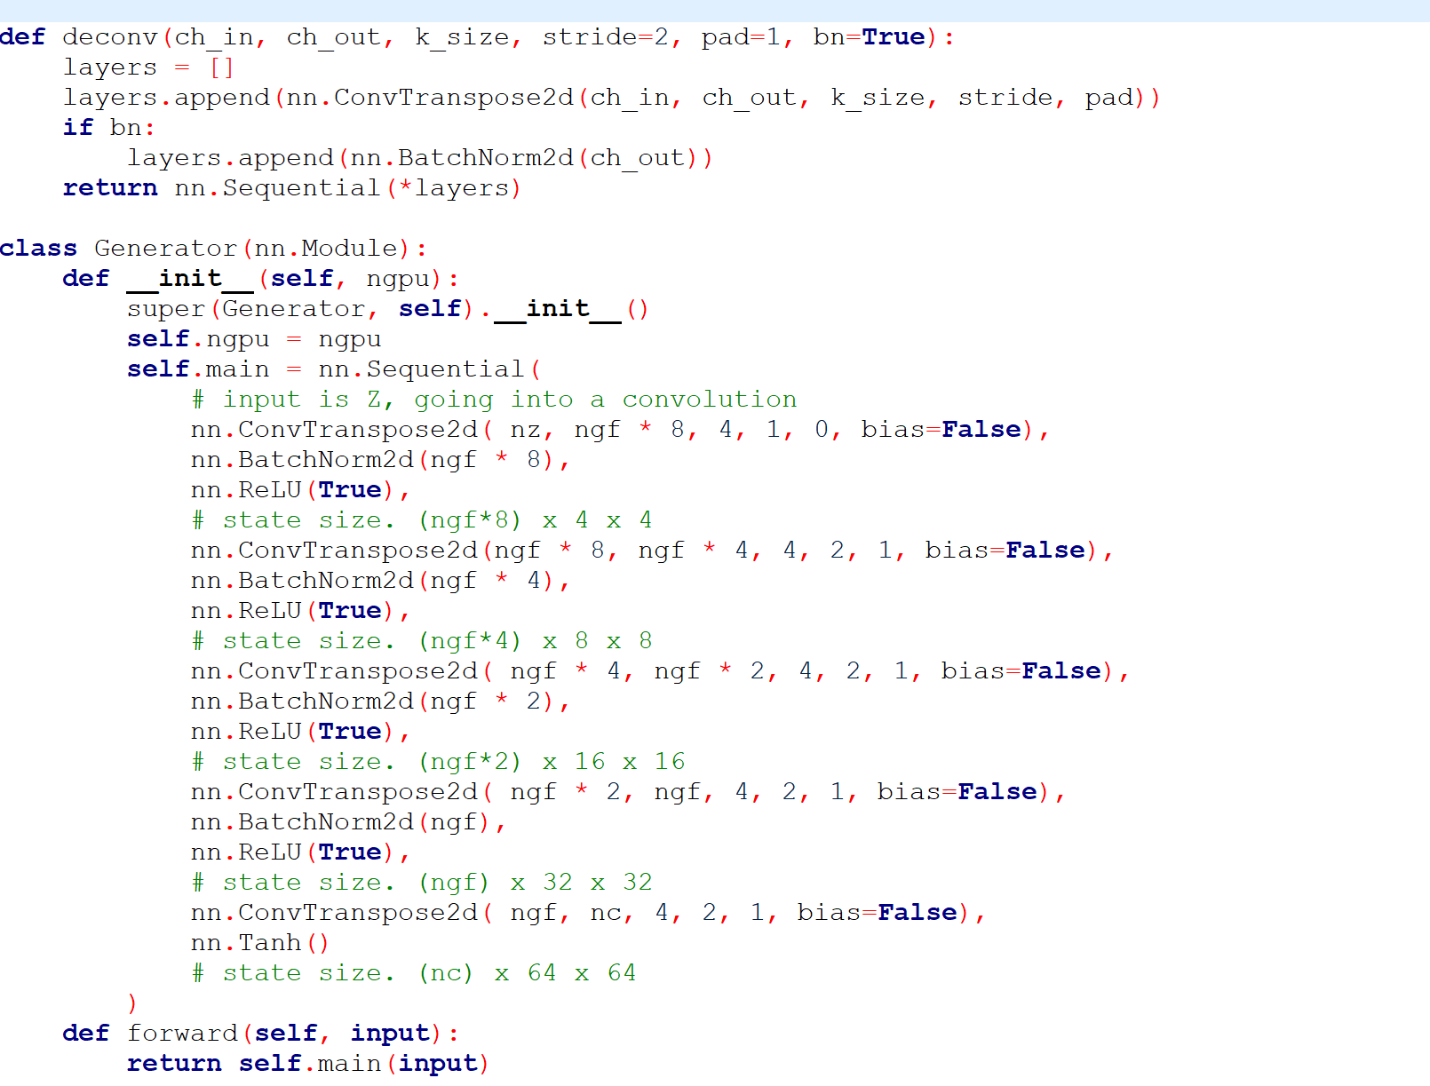

* The second is the Discriminator model whose end goal is to identify that the input data entered is original that is the same as the original dataset or if it is the fake data that the generator has created. The Discriminator is the same as one of the art experts, trying to predict the original and fake. The designed discriminator model for this project was able to predict the real and fake images separately for the celebrity images of the dataset

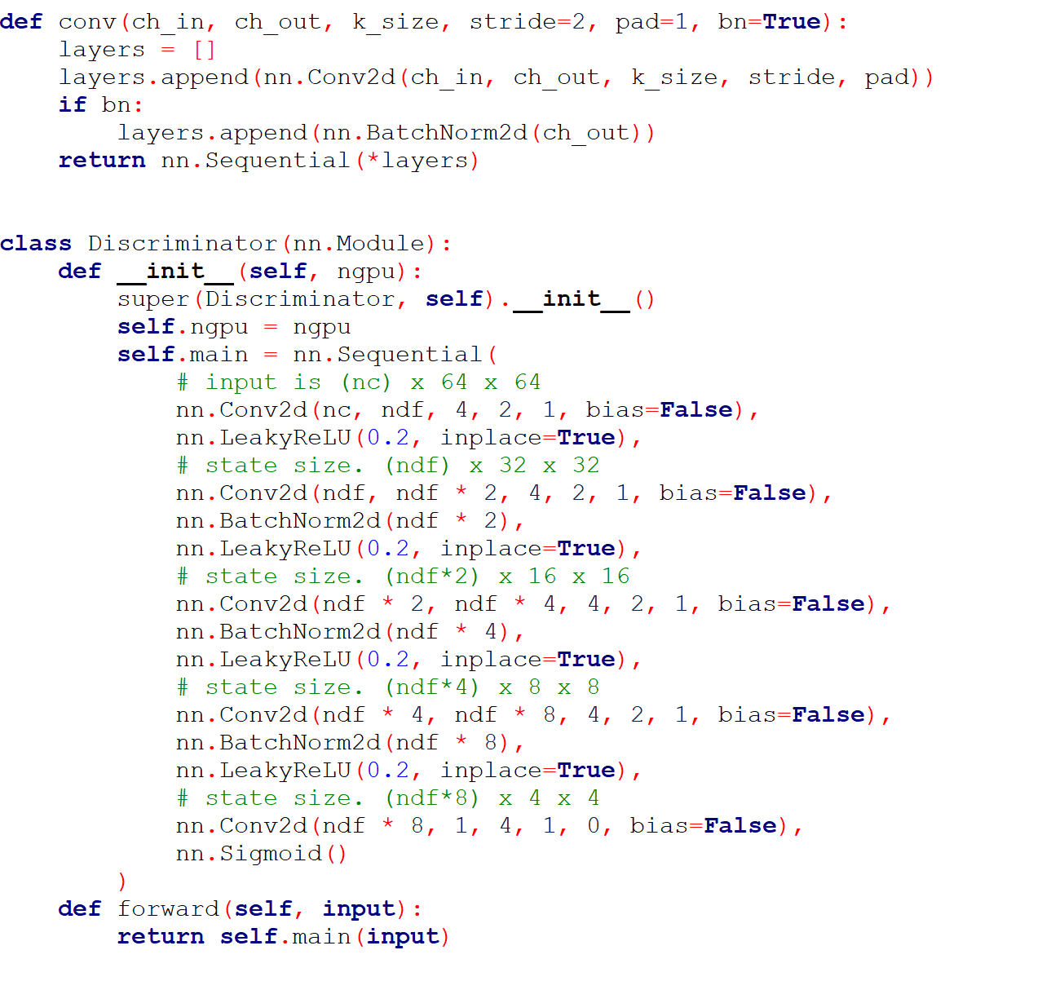

Functions used in the GAN Model

1. Activation Function: Sigmoid and ReLu as this is more computationally efficient and has better convergence.
2. Batch Normalization is good to check if each node can learn.
3. Loss Function: BCE Loss (Binary Cross Entropy) as it needs only one node to classify the data into 2 classes.

**Step 4: Parallelizing the models with multiple GPU’s using Cuda Module**

* Parallelizing CNN gender model and hair feature model on 1,2 and 4 GPU’s

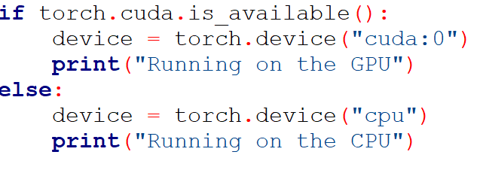

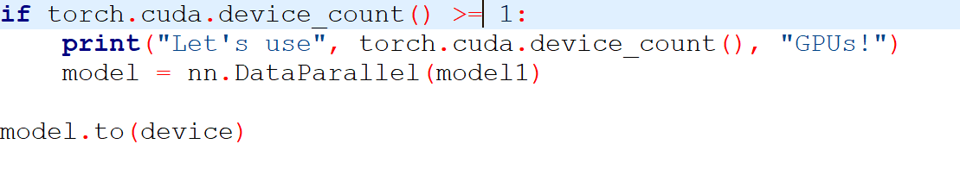

* Parallelizing GAN on Multiple GPU’s



Generator

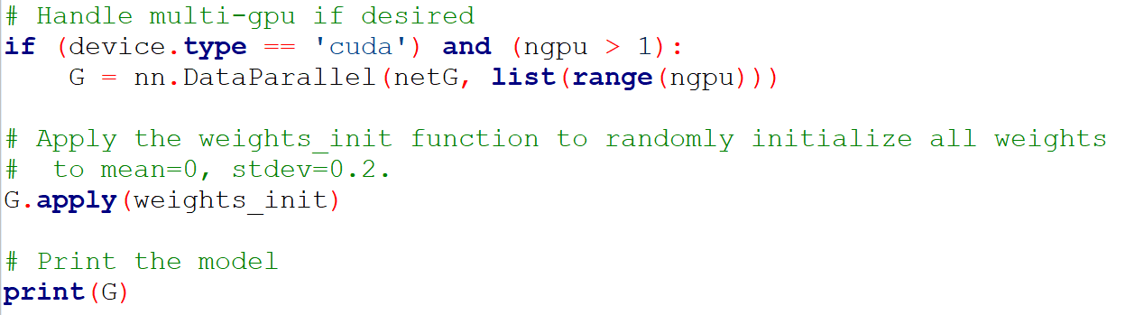

Discriminator

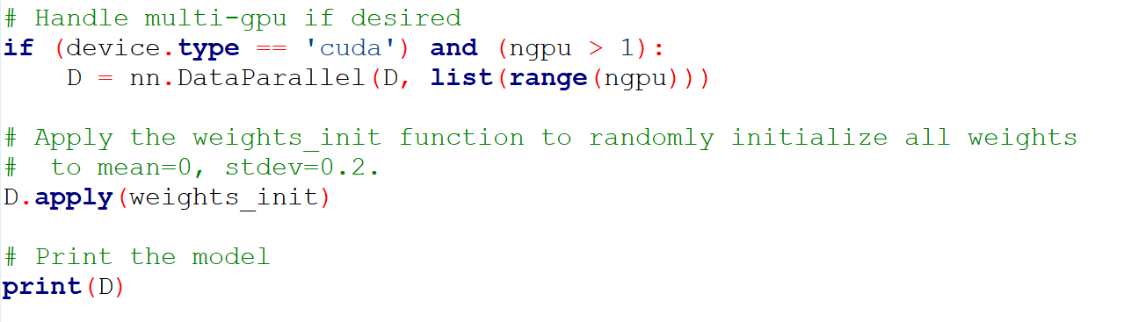

1. **Description of the dataset**

The dataset is a celebrity image dataset that is created by the researchers of MMLAB. The dataset contains 202599 images of different celebrities. The total size of the dataset is 1.35GB and has5 data files namely:

* img_align_celeb: This folder contains all the images that are properly aligned and cropped
* list_eval_partition.csv: This csv file has the partitioning values of images into training, validation, testing sets which is as the images from 1 to162770 are training, 162771 to 182637 are validation and 182638 to 202599 are testing images
* list_box_celeba.csv: This file has the bounding box information for each image. "x*1" and "y*1" represent the upper left point coordinate of the bounding box. "width" and "height" represent the width and height of bounding box
* list_and_mark_align_celeba.csv: The image landmarks and their respective coordinates are present in this file. There are 5 landmarks: left eye, right eye, nose, left mouth, right mouth
* list_attr_celeba.csv: This is a file with attribute labels for each image. There are 40 attributes. "1" represents positive while "-1" represents negative

In this project we have worked on the img_align_celeb,list_eval_partition.csv and list_attr_celeba.csv files as these consist of the data we required to perform our goal. In the CNN model we used the list_attr_celeb.csv, img_align_celeb and list_eval_partition.csv. The list_attr_celeba.csv which has the column named ‘Male’ which can be used for gender prediction as Male and Female and also there are 4 different hair colors namely Black,Brown,Blond and Gray, which we used in the hair feature prediction. The img_align_celeb which consist of the images of different celebrities and the list_eval_partition.csv has the partition values as 0,1,2 for train, validation and test data split. In the GAN’s model we used the image folder img_align_celeb to generate the fake faces

The link for the dataset is:

<https://www.kaggle.com/jessicali9530/celeba-dataset>

Heatmap Plot for the attributes in the dataset

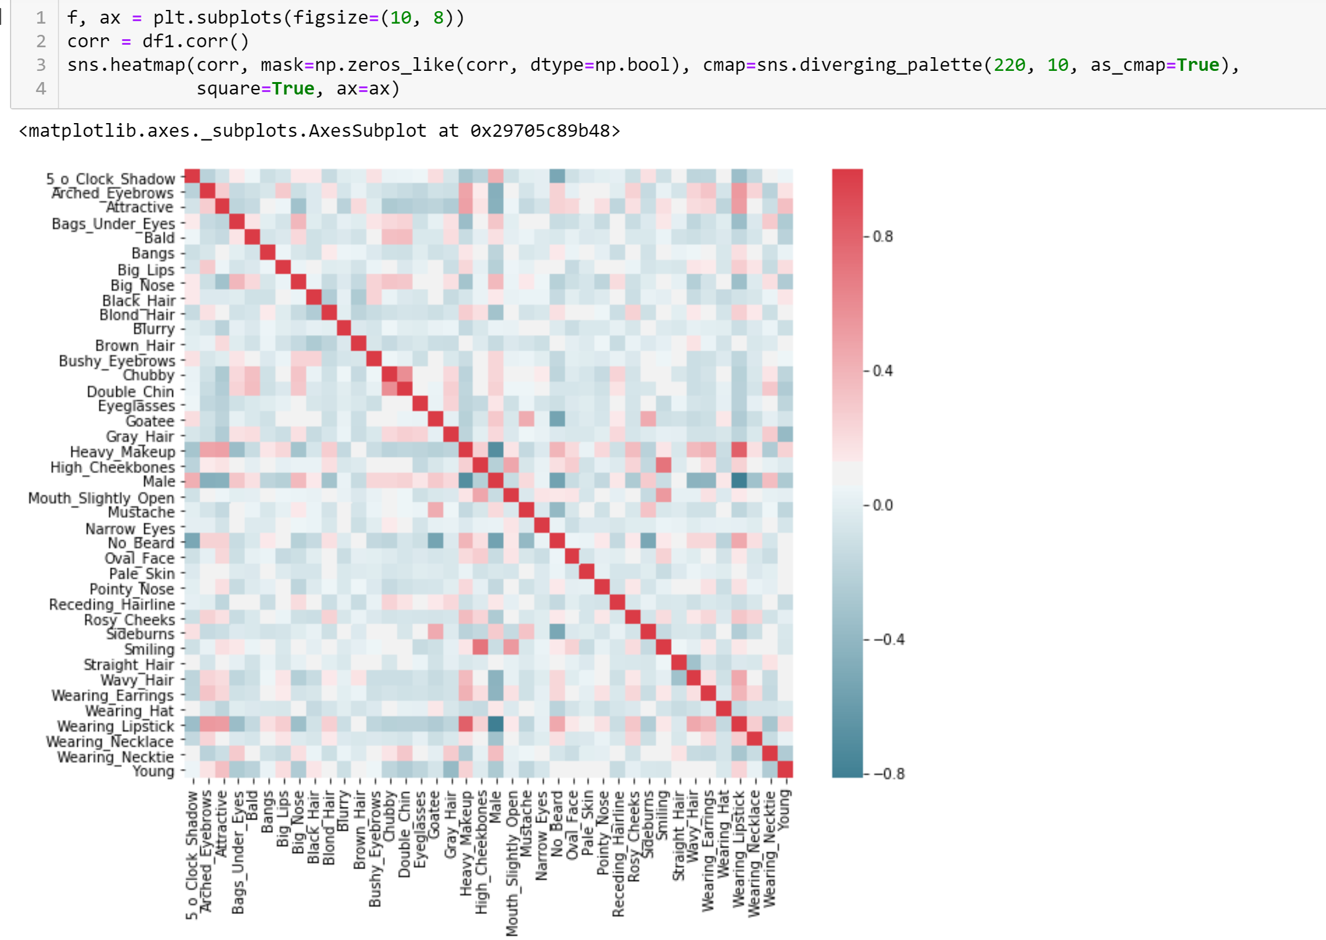

**6. Result and Analysis**

* Gender Model Prediction with CNN

Model execution:

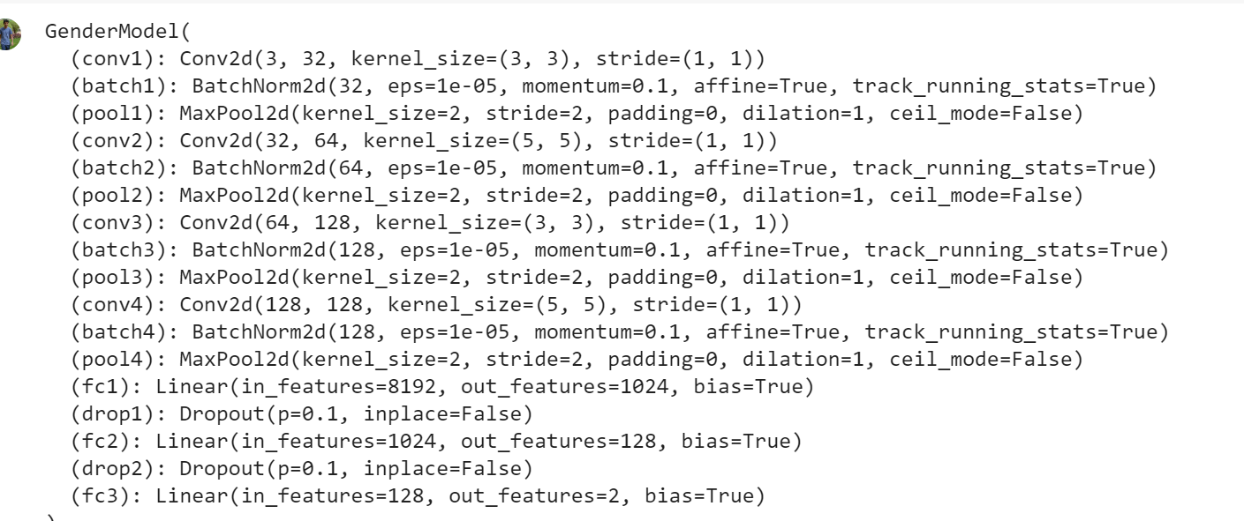

**The Plot for loss and Accuracy:**

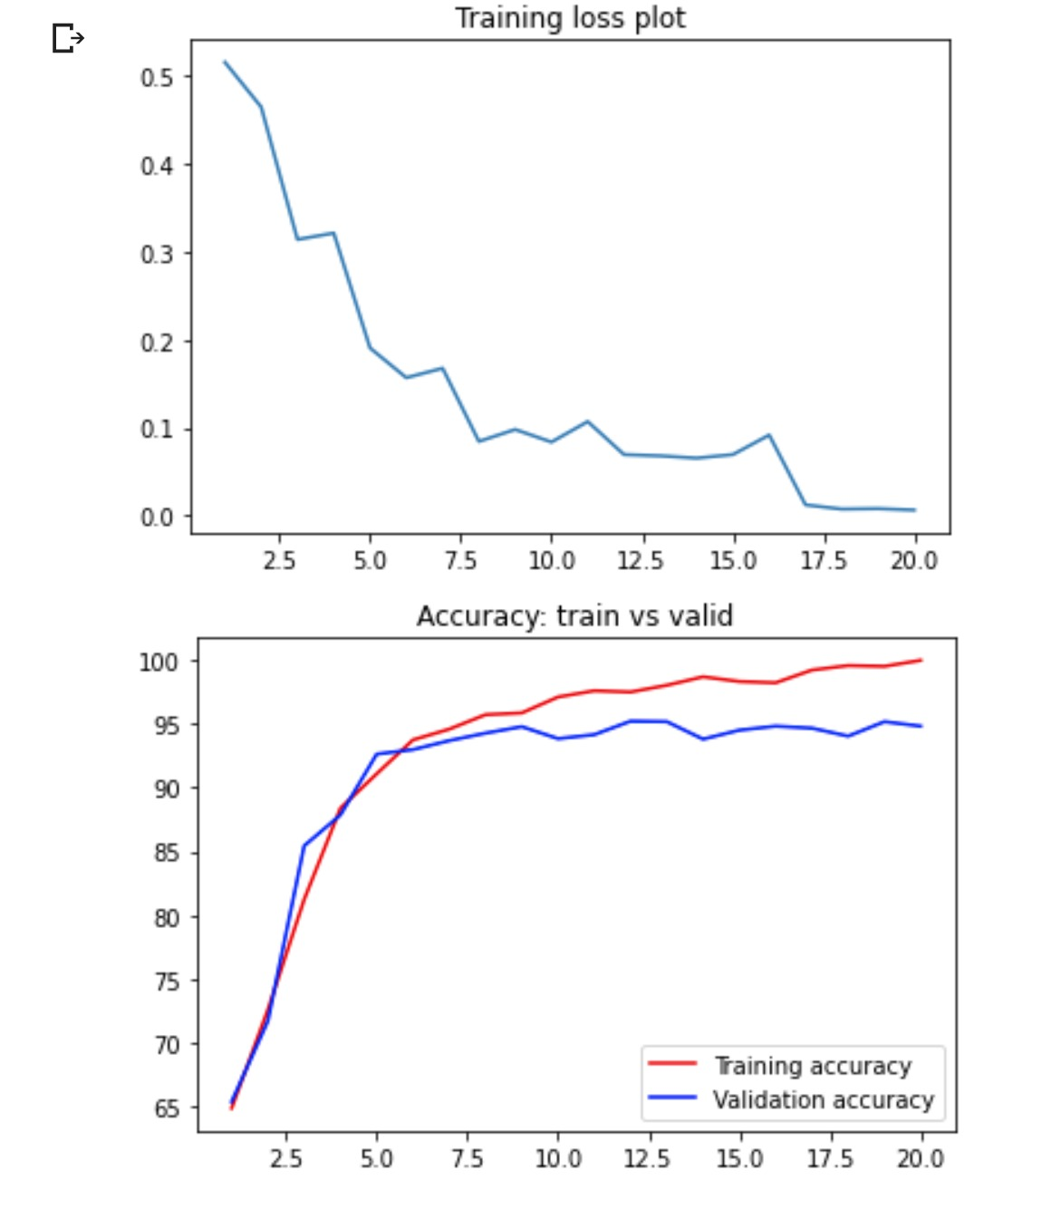

**The final outcomes from the Gender model:**

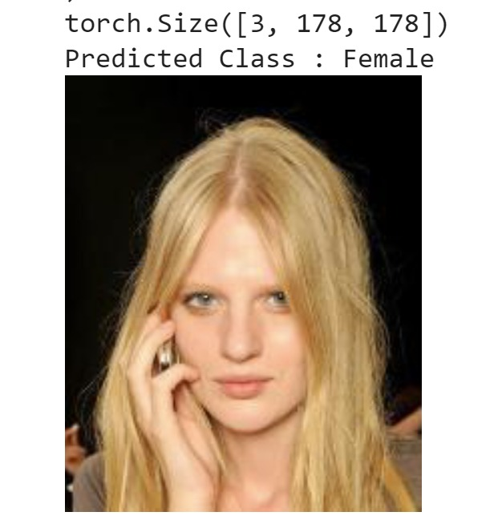 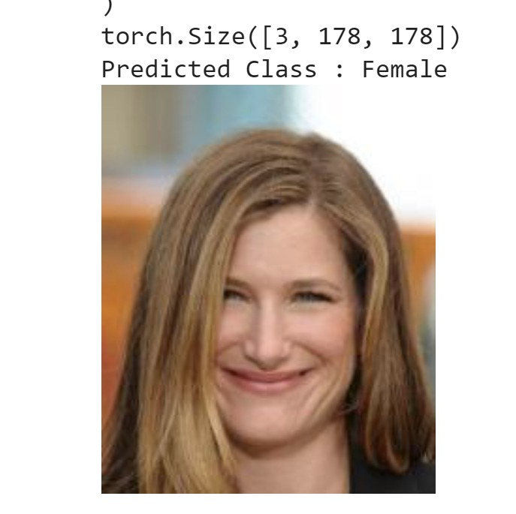

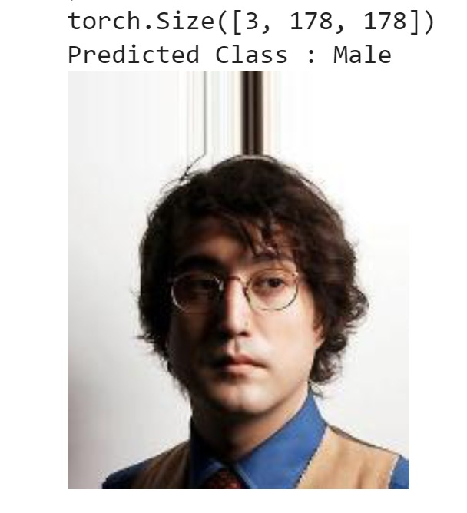 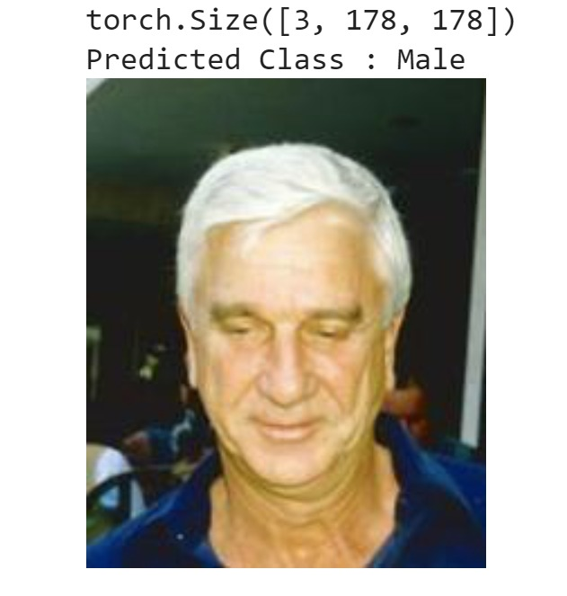

* Hair Feature Prediction With CNN

Model Execution:

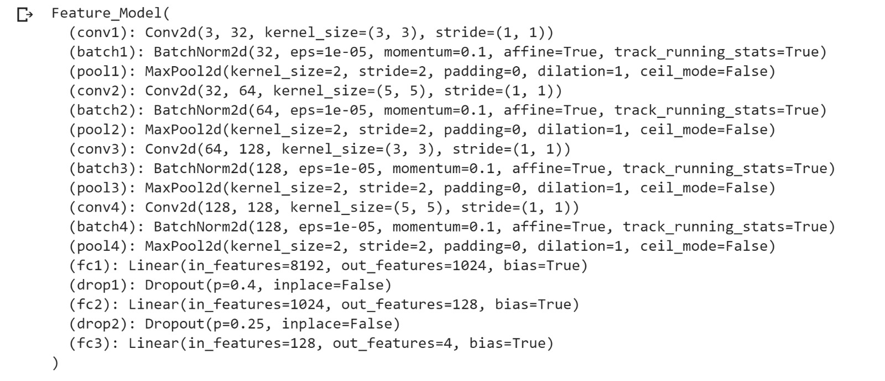

**The Plot of loss and accuracy :**

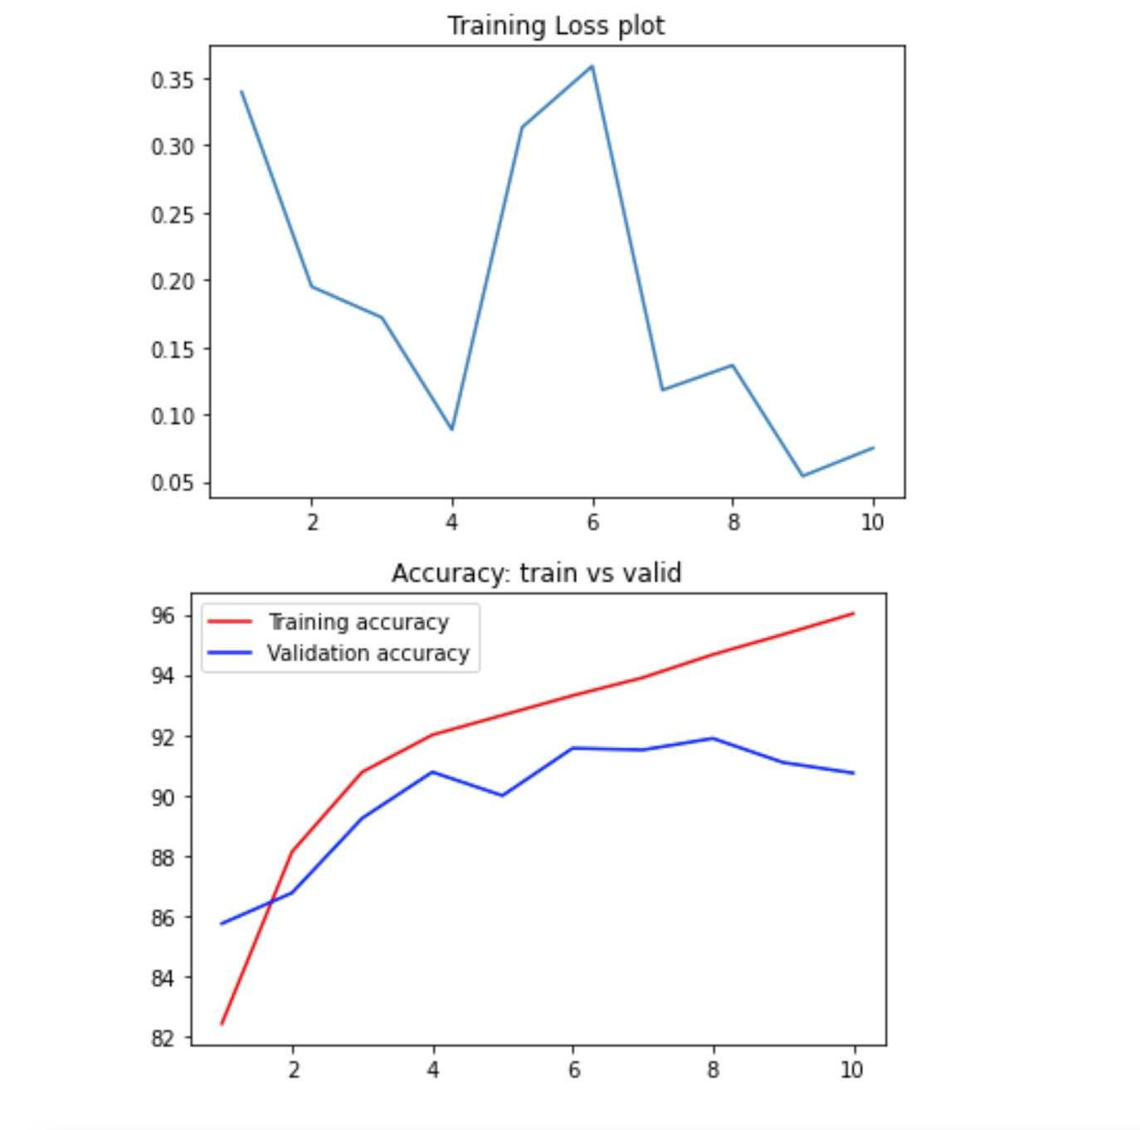

**The final outcomes from the model:**

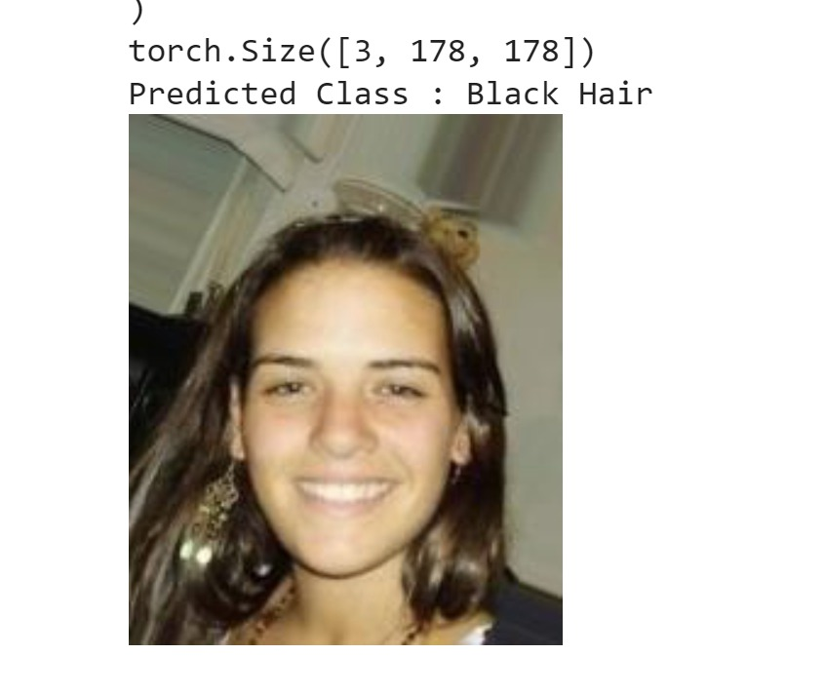 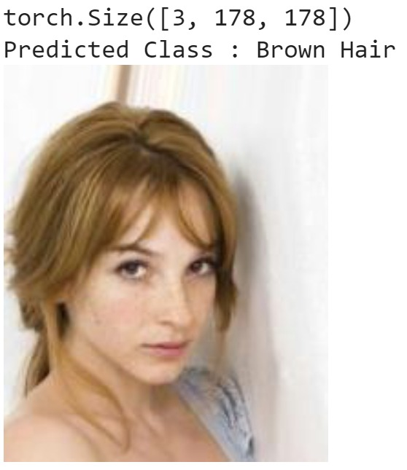

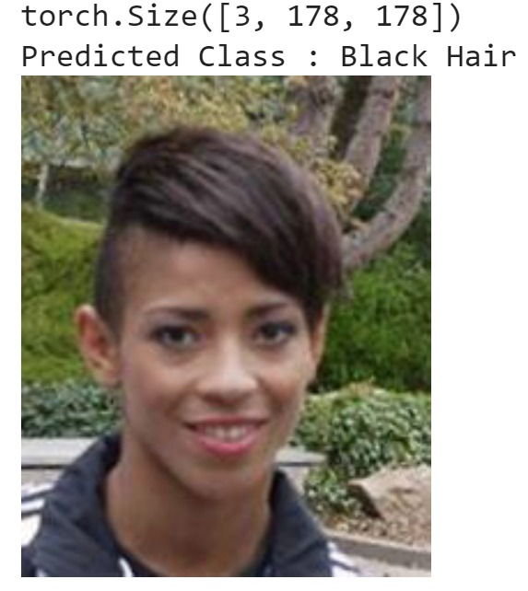 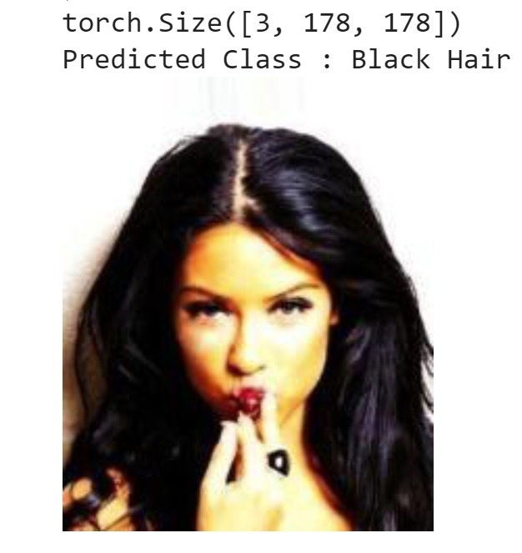

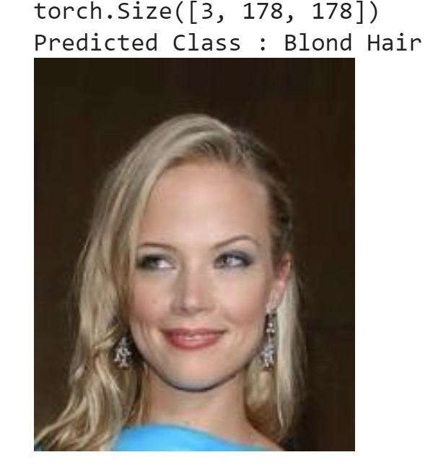 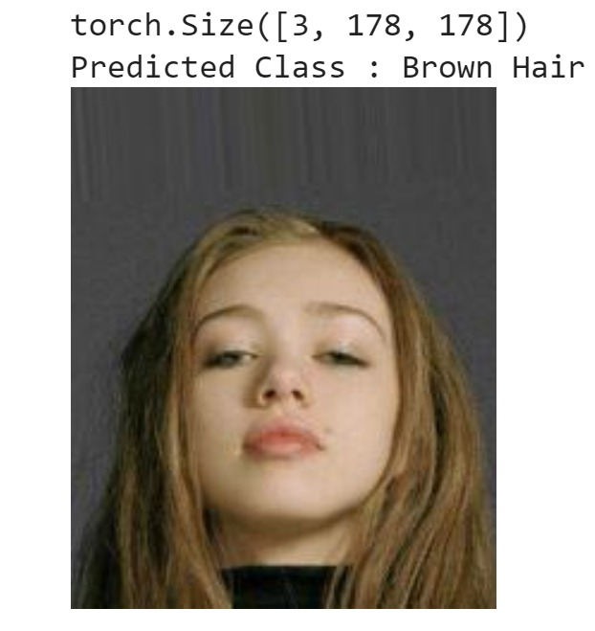

* **GAN Results:**

**Model execution:**

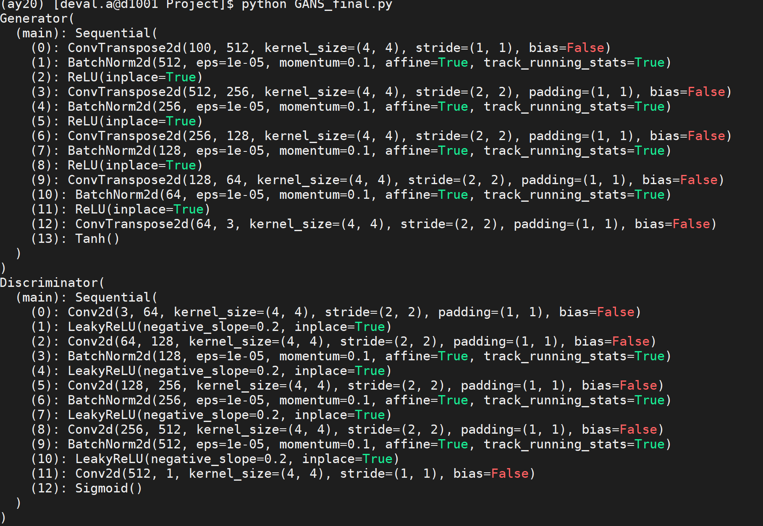

**The plot of Losses for generator and discriminator:**

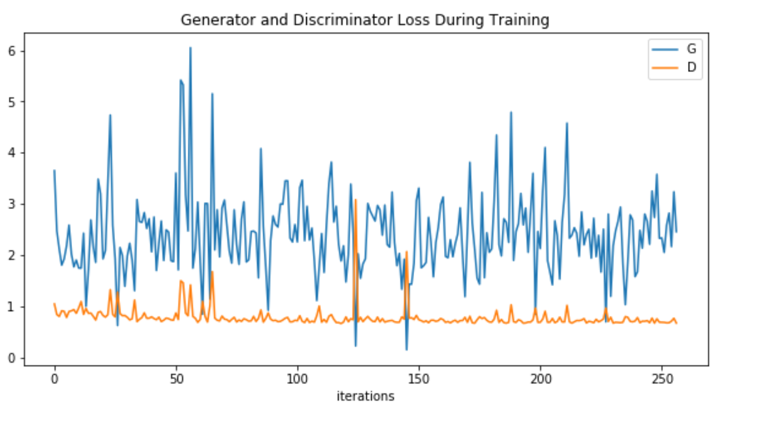

**Real Images:**

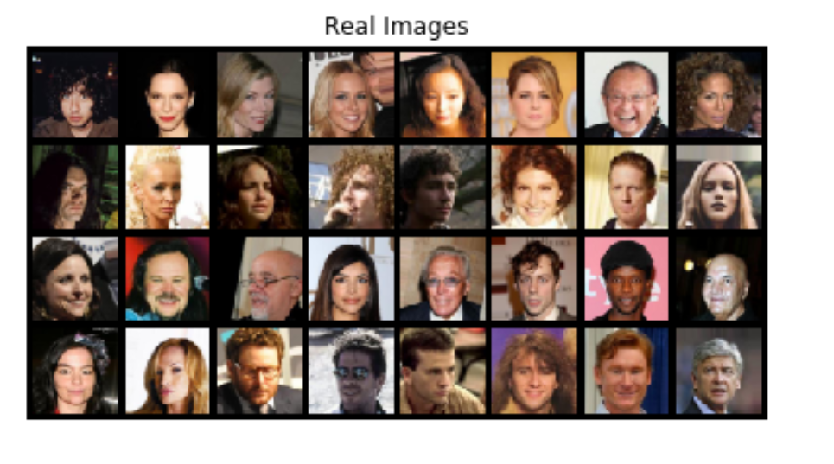

**Fake Image :**

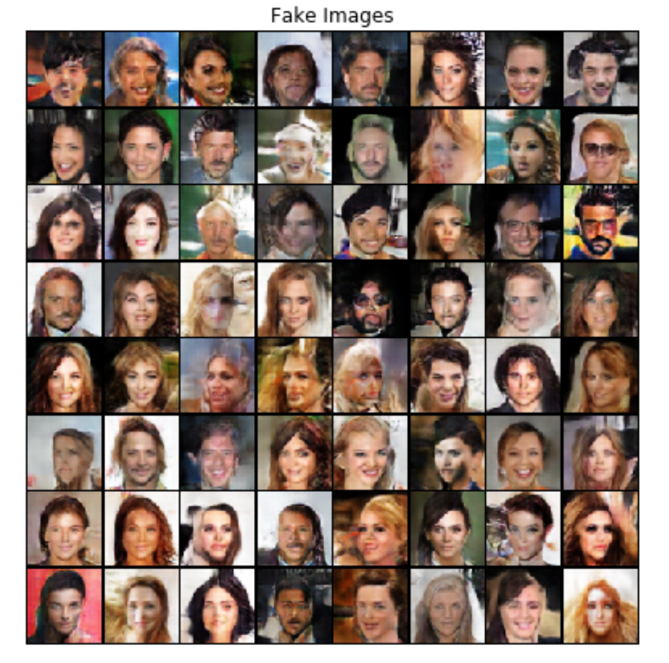

**Data Parallelism:**

The models were parallelized on Data parallelism on the cluster with multiple GPU’s.

Starting with requesting resource on the cluster and additional memory of 4GB



* **Gender Model using CNN with pytorch and parallelizing it using Cuda device on 1,2 and 4 GPU’s**

While running on 1 GPU we obtained training accuracy of 91% and validation accuracy of 92% and a total time of 92.65 seconds

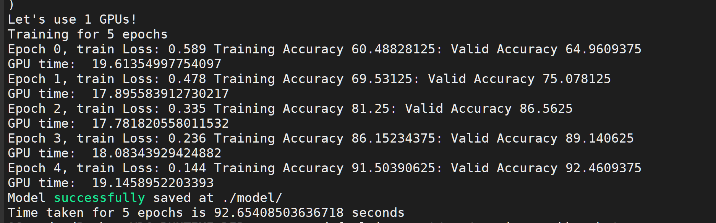

On 2 GPU’s the computing time reduced by 14 seconds and became 78.35 seconds and the training accuracy was 91% and validation accuracy came out to be 93%

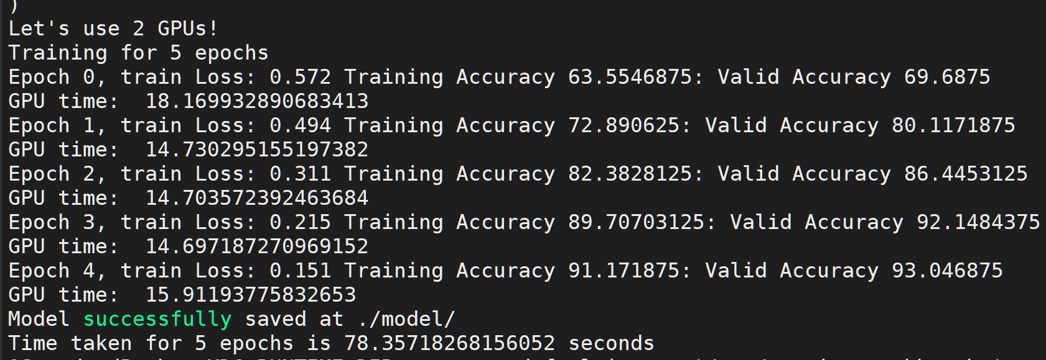

On 4 GPU’s the reduced by 6 seconds from the 2 GPU computing time, and we noted it as 72.73 seconds. The training and validation accuracies were 92%

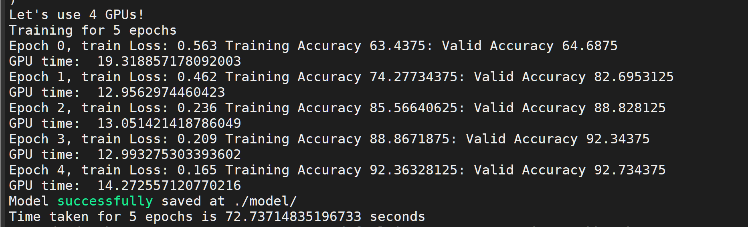

* **Hair Feature Model using CNN with pytorch and parallelizing it using Cuda device on 1,2 and 4 GPU’s**

On 1 GPU the time taken was the highest , 2331.72 seconds with the accuracies of 92% and 90% for training and validation respectively.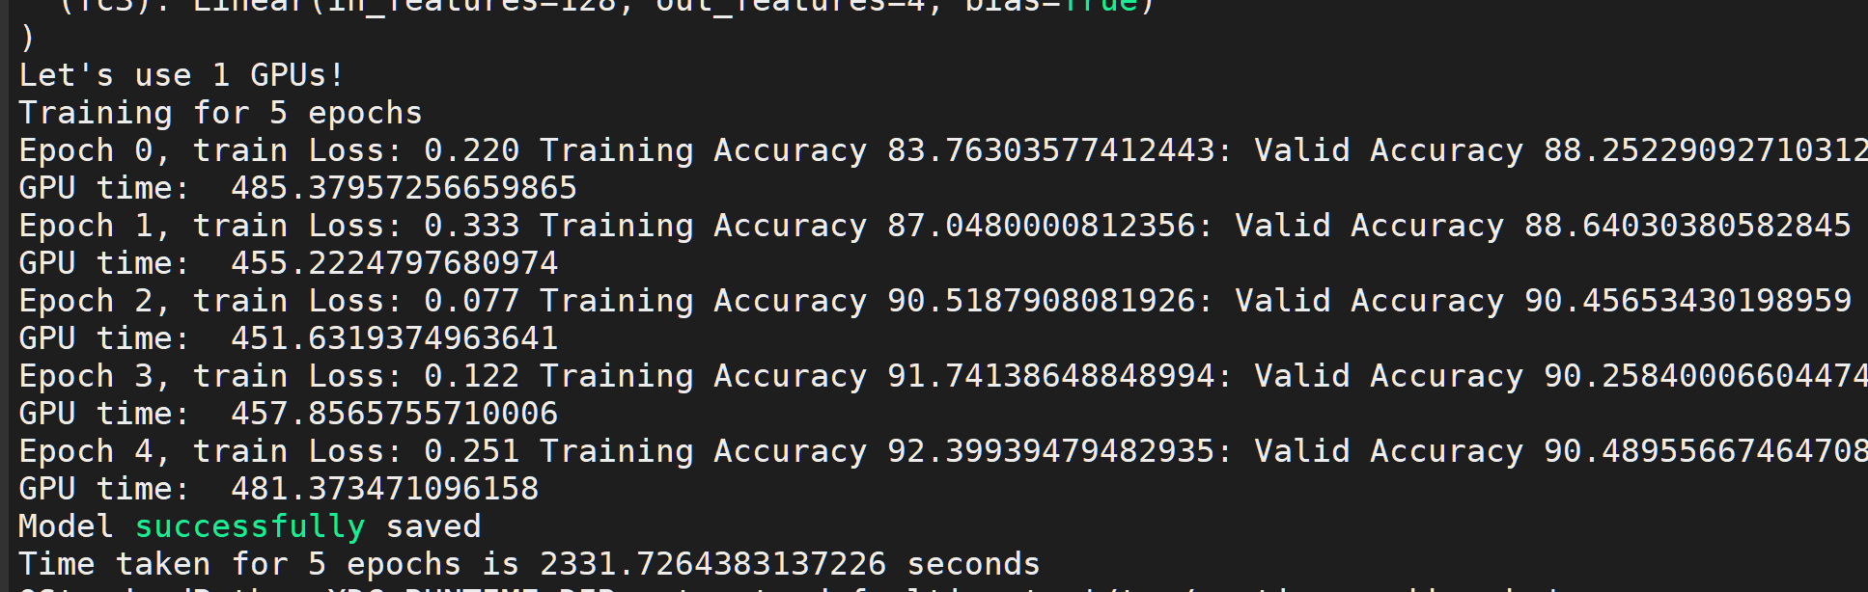

Running on 2 GPU’s we encountered the accuracies to be same as fo 1 GPU ie 92% and 90% for training and validation respectively but the total computing time reduced to 1912.40 seconds

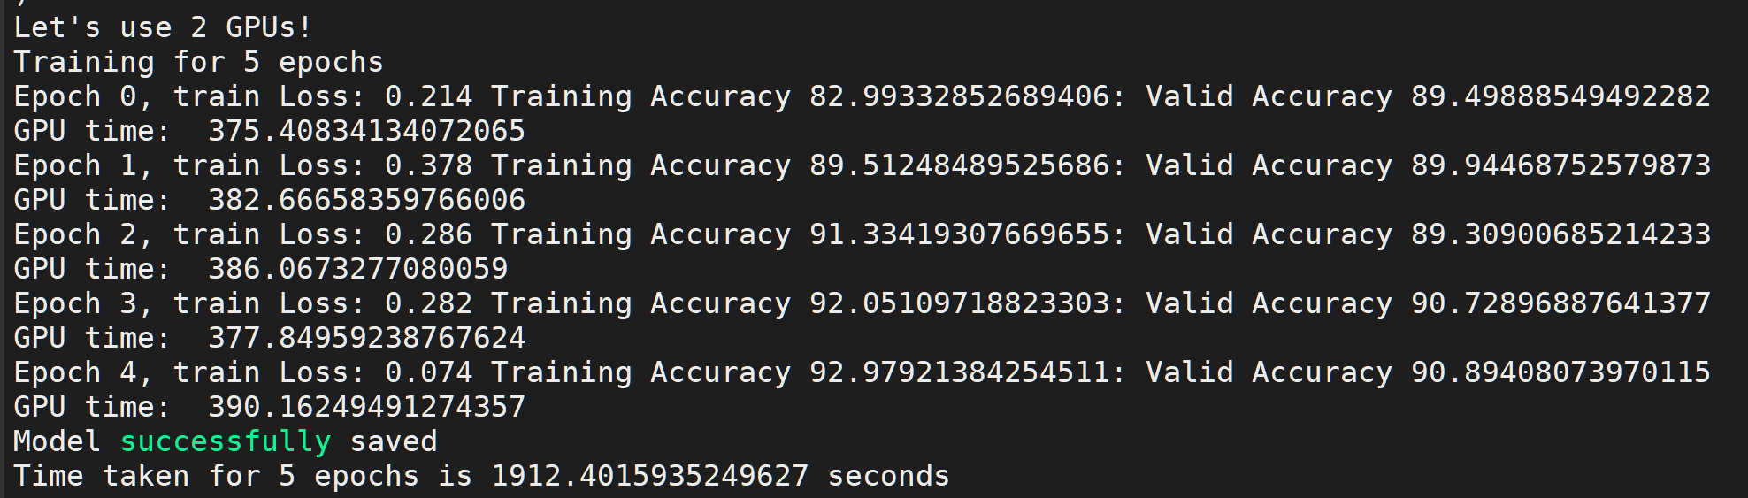

Running on 4 GPU’s the computing time was 1711.91 seconds with training accuracy as 92% and validation accuracy og 91%

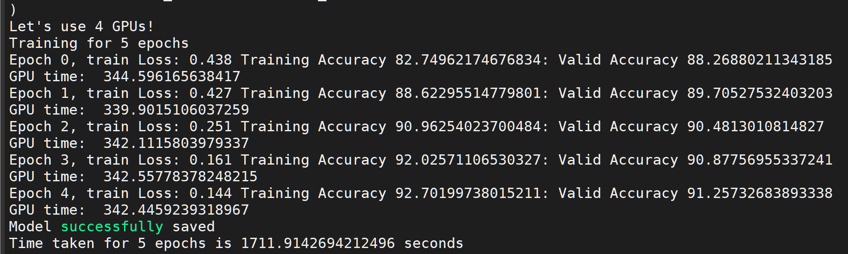

* **GAN model parallelism on cuda device on 1,2 and 4 GPU’s**

For 4 GPU’s the computing time of each epoch was 4500 seconds and the

resultant loss function for Generator was 0.4 and Discriminator was 1.1

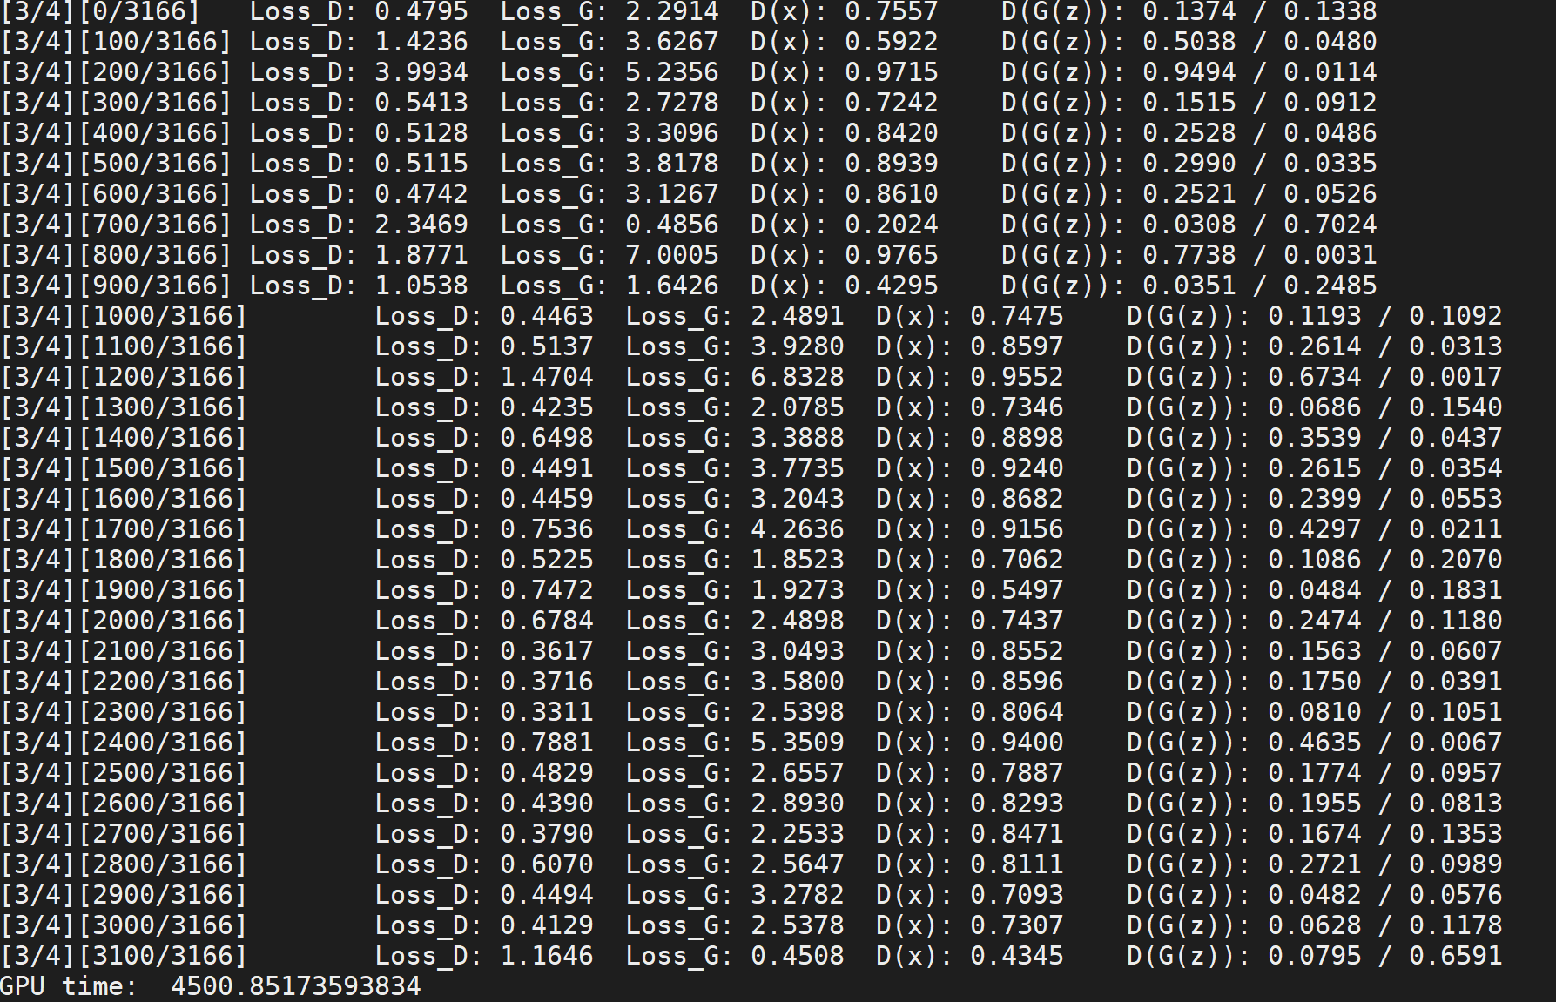

Computing time on 1 GPU for each epoch was 9550 seconds double of the 4 GPU result and the loss for Generator and Discriminator were 3.03 and 0.4 respectively.

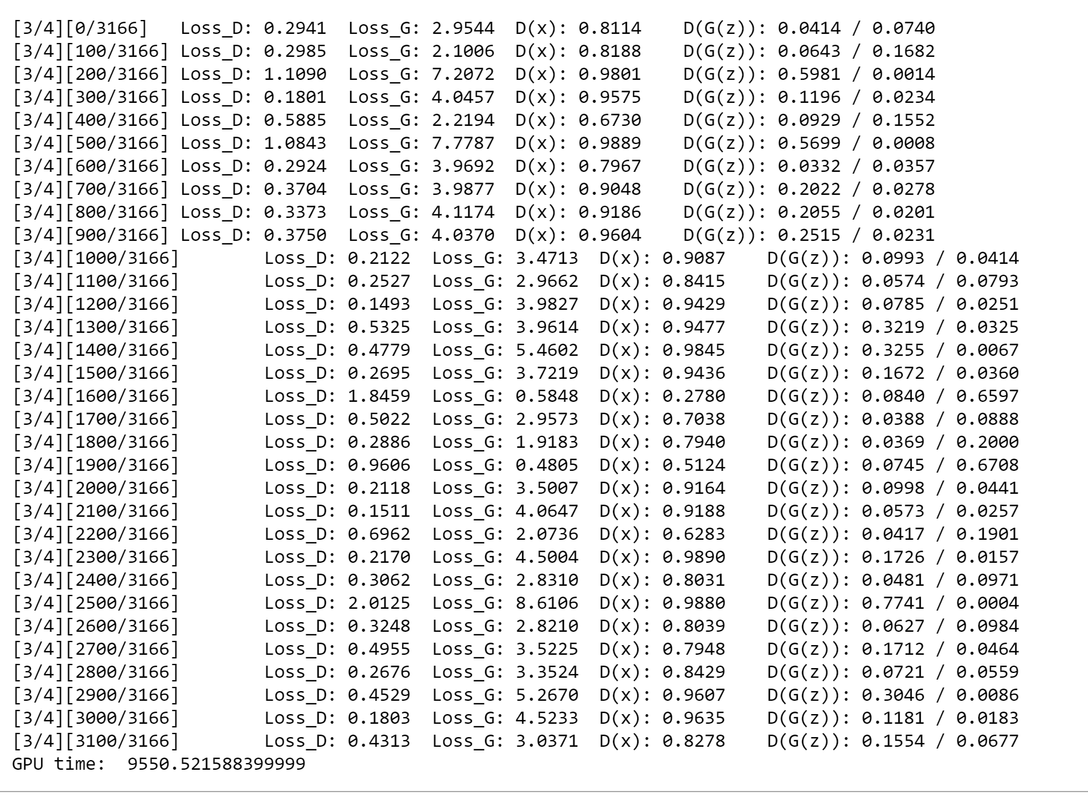

**7. Conclusion**

With deep learning methodologies like CNN and GANs we were able to achieve the goal we set at the starting of our project. The CNN models accurately predict the Gender and the hair colours reading through the celebrity images. With an accuracy of 92%. In the GAN model the two components i.e. the generator and the discriminator performed the task well with one generating the fake images and the other identifying between the fake and the real once.

**8. References.**

1. [**https://www.kaggle.com/jessicali9530/celeba-dataset/notebooks**](https://www.kaggle.com/jessicali9530/celeba-dataset/notebooks)
2. [**https://stackoverflow.com/questions/43288550/iopub-data-rate-exceeded-in-jupyter-notebook-when-viewing-image**](https://stackoverflow.com/questions/43288550/iopub-data-rate-exceeded-in-jupyter-notebook-when-viewing-image)
3. [**https://pytorch.org/tutorials/beginner/blitz/data_parallel_tutorial.html**](https://pytorch.org/tutorials/beginner/blitz/data_parallel_tutorial.html)
4. [**https://analyticsindiamag.com/multi-label-image-classification-with-tensorflow-keras/**](https://analyticsindiamag.com/multi-label-image-classification-with-tensorflow-keras/)
5. [**https://www.kaggle.com/waltermaffy/create-fake-face-with-pytorch**](https://www.kaggle.com/waltermaffy/create-fake-face-with-pytorch)
6. [**https://stackoverflow.com/questions/45303186/delete-row-from-file-using-csv-reader-and-lists-python**](https://stackoverflow.com/questions/45303186/delete-row-from-file-using-csv-reader-and-lists-python)
7. [**https://stackoverflow.com/questions/44613507/typeerror-join-argument-must-be-str-or-bytes-not-nonetype**](https://stackoverflow.com/questions/44613507/typeerror-join-argument-must-be-str-or-bytes-not-nonetype)
8. [**https://www.kaggle.com/c/jigsaw-unintended-bias-in-toxicity-classification/discussion/91081**](https://www.kaggle.com/c/jigsaw-unintended-bias-in-toxicity-classification/discussion/91081)
9. [**https://pytorch.org/tutorials/beginner/dcgan_faces_tutorial.html**](https://pytorch.org/tutorials/beginner/dcgan_faces_tutorial.html)
10. [**https://medium.com/ai-society/gans-from-scratch-1-a-deep-introduction-with-code-in-pytorch-and-tensorflow-cb03cdcdba0f**](https://medium.com/ai-society/gans-from-scratch-1-a-deep-introduction-with-code-in-pytorch-and-tensorflow-cb03cdcdba0f)
11. [**https://rc-docs.northeastern.edu/en/latest/software/software.html**](https://rc-docs.northeastern.edu/en/latest/software/software.html)
12. [**https://rc-docs.northeastern.edu/en/latest/using-discovery/transferringdata.html**](https://rc-docs.northeastern.edu/en/latest/using-discovery/transferringdata.html)
13. [**https://pytorch.org/tutorials/**](https://pytorch.org/tutorials/)
14. [**https://stackoverflow.com/questions/55274469/slurm-python-multiprocessing-exceed-memory-limit**](https://stackoverflow.com/questions/55274469/slurm-python-multiprocessing-exceed-memory-limit)
15. [**https://forum.qt.io/topic/108466/installation-error-qstandardpaths-xdg_runtime_dir-not-set-defaulting-to-tmp-runtime-root/4**](https://forum.qt.io/topic/108466/installation-error-qstandardpaths-xdg_runtime_dir-not-set-defaulting-to-tmp-runtime-root/4)
16. [**https://towardsdatascience.com/how-to-train-an-image-classifier-in-pytorch-and-use-it-to-perform-basic-inference-on-single-images-99465a1e9bf5**](https://towardsdatascience.com/how-to-train-an-image-classifier-in-pytorch-and-use-it-to-perform-basic-inference-on-single-images-99465a1e9bf5)
17. [**https://towardsdatascience.com/pytorch-tabular-multiclass-classification-9f8211a123ab**](https://towardsdatascience.com/pytorch-tabular-multiclass-classification-9f8211a123ab)
18. [**https://towardsdatascience.com/understanding-cnn-convolutional-neural-network-69fd626ee7d4**](https://towardsdatascience.com/understanding-cnn-convolutional-neural-network-69fd626ee7d4)